Скопирована база с данными
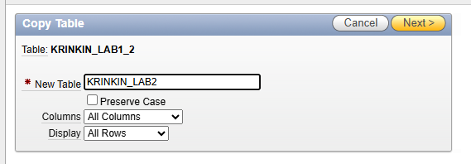
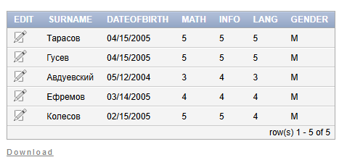

SET LINESIZE 150;

SELECT LAB2.*, (LAB2.MATH+LAB2.INFO+LAB2.LANG)/3 AS AVG
FROM KRINKIN_LAB2 LAB2;

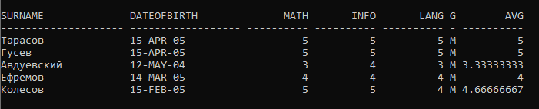
CREATE TABLE KRINKIN_LAB2_BST (
ID NUMBER NOT NULL,
YEAR NUMBER(4,0) NOT NULL,
AMOUNT NUMBER
);

INSERT INTO KRINKIN_LAB2_BST (ID, YEAR, AMOUNT)
VALUES (1, 2025, 2440);
INSERT INTO KRINKIN_LAB2_BST (ID, YEAR, AMOUNT)
VALUES (1, 2026, 2880);

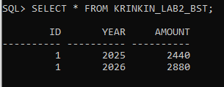

SELECT LAB2.*,
CASE
WHEN LAB2.AVG > 4.5 THEN (AMOUNT * 1.5)
WHEN 3.5 < LAB2.AVG AND LAB2.AVG <= 4.5 THEN (AMOUNT * 1.25)
WHEN 2.5 < LAB2.AVG AND LAB2.AVG <= 3.5 THEN (AMOUNT)
ELSE 0
END AS REWARD
FROM (
SELECT TAB.*,
(TAB.MATH + TAB.INFO + TAB.LANG) / 3 AS AVG
FROM KRINKIN_LAB2 TAB
) LAB2
LEFT JOIN KRINKIN_LAB2_BST BST ON BST.YEAR = :Year;
SELECT LAB2.*,
CASE
WHEN LAB2.AVG > 4.5 THEN (TO_NUMBER(:BaseAmount) * 1.5)
WHEN 3.5 < LAB2.AVG AND LAB2.AVG <= 4.5 THEN (TO_NUMBER(:BaseAmount) * 1.25)
WHEN 2.5 < LAB2.AVG AND LAB2.AVG <= 3.5 THEN (TO_NUMBER(:BaseAmount))
ELSE 0
END AS REWARD
FROM (
SELECT TAB.*,
(TAB.MATH + TAB.INFO + TAB.LANG) / 3 AS AVG
FROM KRINKIN_LAB2 TAB
) LAB2;

